

FSE100 Spring 2016

Lab manual created by Dr. Yinong Chen



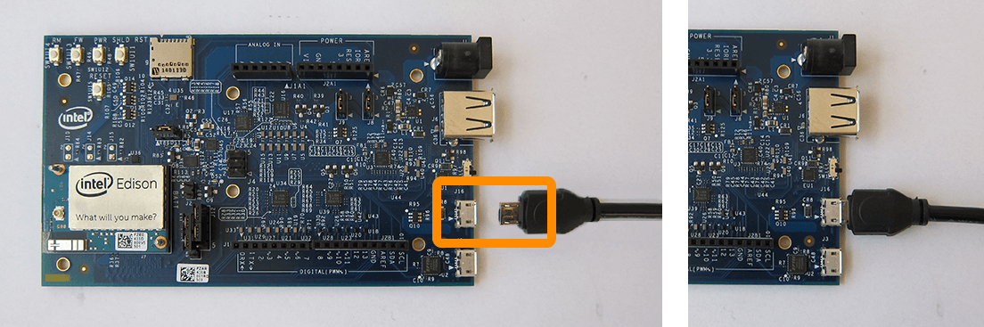

# Lab 9 Robot Hardware and Software for VIPLE Environment

**Overview**

In this lab, you will construct a physical robot using a processor board, sensors actuators, and a robot chassis. You will install an operating system and VIPLE middleware on the processor board. The VIPLE middleware will send sensory data to the VIPLE and receive commands from VIPLE to control the motors.

You may need to split your team into a hardware group and a software group.

## Section 1. **IoT Computing Model**

As discussed in the previous lab session, ASU VIPLE is a programming environment with general-purpose functions, as well as IoT/Robotic specific functions. Three sets of services are implemented: General computing services, generic robotic services, and vendor-specific robotic services. We used the services for simulated robot in the previous lab session, and we will focus on the services for physical robot in this and in the following labs.

When using ASU VIPLE as an IoT/Robotics environment, it consists of two systems. VIPLE is running on a normal PC at the backend, while the IoT device or robot is running as the frontend computer that communicates with the VIPLE program, as shown in Figure 1.



1. VIPLE code testing generic sensors

The two systems can communicate with each other through one of the following communication protocols:

* Wi-Fi: This is the common and the best way of connection. There are two connection modes using Wi-Fi:
  + Infrastructure mode through a Wi-Fi router. When both the backend PC and the frontend robot are connected to the same router, the two systems are connected. In this mode, the robot will connect to the router and acquire a physical IP address.
  + Ad Hoc mode where the PC connects directly to the robot. In this connection mode, the frontend robot computer is considered to be a router, and the backend PC directly connects to the robot. In this mode, the robot computer is given a virtual IP address.
* Bluetooth: In this mode, the backend computer considers the robot as a Bluetooth device, and uses the computer’s Add Bluetooth Device function to connect to the robot.
* USB: As the robot is a mobile device. It is not ideal to use USB to connect the PC to the robot. However, when wireless connections are not available or when we are debugging our robot, USB connection presents a reliable way of communication.

Once the two systems are connected, we need to define data format for data exchange between the VIPLE and the robot.

ASU VIPLE supports an open interface to other robotic platforms. Any robot that follows the same interface and can interpret the commands from a VIPLE program can work with VIPLE. A VIPLE program communicates with the robot using the standard JSON (JavaScript Object Notation) object shown in Figure 2, which defines the input to the robot from the VIPLE program and the output from the robot to the VIPLE program.

The VIPLE environment encodes the command information into this object. The robot needs to interpret the commands and perform the actions defined. On the other hand, the robot encodes the feedback in the same JSON format and sends the object back to the VIPLE program. Then, the VIPLE program will extract and use the information to generate the next actions.

The standard JSON object defined for the communication consists of pairs of {name : data} to define the data objects to be exchanged, as shown in Figure 2.

* Robot Output: The robot will send sensory data to VIPLE program. The data is a pair {“Sensors” : <values>}, where <values> is an array of pairs. Each element of the array consists of two pairs, which define four pieces of information: “name” : <sensor name>, “id”: <id_number>, “value” : <value>. The values shown in Figure are examples.
* Robot Input: The robot will receive command data from VIPLE program. The data is a pair {“Servos” : <values>}, where <values> is an array of pairs. Each element of the array consists of two pairs, which define four pieces of information: “servoId”: <id_number>, “servoSpeed”: <speed_value>. The values shown in Figure are examples.



1. VIPLE code testing generic sensors

## Section 2. Install Software on Edison Robot

### **1. Hardware Group: Install the Edison Board**

The hardware group will start with e following installation.



The hardware group will had the installed board to the software group to install software.

### **2. Install Robot Body**

Follow the diagram to install the body. Notice that you will need to calibrate the servo motor and you may need to remove the motors from their mounts. Do not make the installation permanent at this time.



Next, you will install the sensors to the Edison Board.











Note: Edison Board can be attached in either orientation

 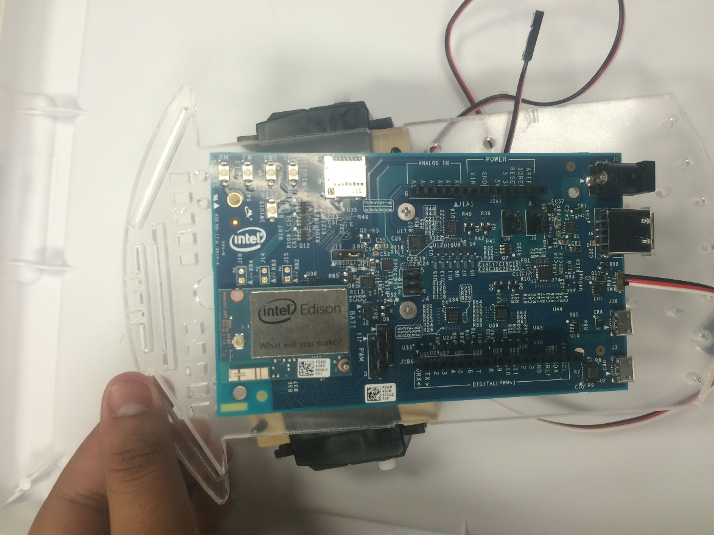

Final Assembly









Using the breadboard to connect power lines.

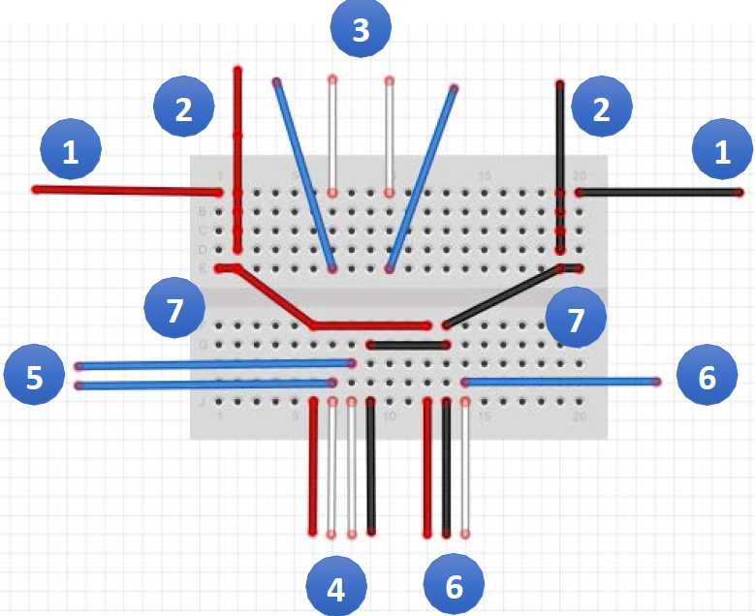

Above is the diagram for the basic breadboard wiring setup with numbered steps. Here is the color-coded key for the diagram:

**RED wires**: 5V Power

**BLACK wires**: Ground (COM)

**WHITE wires**: Sensor Signal wires

**BLUE wires**: Edison I/O wires

Below are the steps for wiring the sensors and motors on the robot to the Edison breakout board.

Step 1:

Connect power wires from Edison to the breadboard as shown in the diagram. The RED wire should be connected to the 5V output on the Edison board.

The BLACK wire should be connected to the GND output on the Edison board

Step 2:

Connect the RED and BLACK outputs of the motors to the breadboard.

Step 3:

Connect digital pins **5** and **6** from the Edison to the breadboard.

Connect the WHITE output from the motors to the breadboard in the same row.

*Note: Pin 5 is for the left motor, and pin 6 is for the right motor.*

Step 4:

Connect the 4 outputs of the Ultrasonic Sensor to the bottom side of the breadboard.

Step 5:

Connect digital pins **12** and **13** to the same column as the WHITE outputs of the ultrasonic sensor.

*NOTE: Pin 12 is for the ECHO output, and pin 13 is for the TRIG output.*

Step 6:

The touch sensor has 2 outputs: **COM**, **NO**, and **NC**.

Connect the touch sensor to the breadboard. The **NO** output will connect to ground (BLACK).

Connect digital pin **2** to the same column as the **NC** input.

Connect the **COM** ouput to the power (RED input from the Edison).

Step 7:

Connect the RED and BLACK wires from the top half of the breadboard to the bottom half, to share the power and ground sources.

Congratulations! The hardware is done, now it is time to move on to programming your robot.

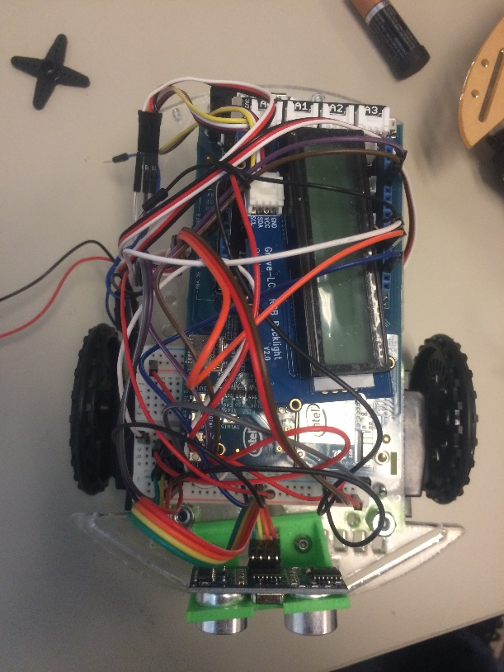

## Section 3. Install Software on Edison Robot

### **1. Install PuTTY on Backend PC**

In order to install the software on Edison, we need to access Edison. After we have installed software on Edison, we also need to access Edison to configure and to start the software. However, the Edison does not have a keyboard nor a monitor screen. We cannot use Edison like a normal computer. We need to connect the Edison to a normal PC through USB first. After we installed OS and configured Wi-Fi, we can use a USB or Wi-Fi to connect to the Edison board. Then, we can use a remote client software, such as SSH or PuTTY, to connect to the Edison board. We will use PuTTY in our lab, which can be downloaded to your PC at the following link:

<http://www.chiark.greenend.org.uk/~sgtatham/putty/download.html>

You can follow these steps to configure and start the program on the Edison.

1. Connect your Edison board to you backend computer through two micro USB cables. One cable will provide power to Edison and one will provide data connection. After you have configured Wi-Fi on Edison, you can either use USB or Wi-Fi for data communication. The switch next to the USB ports on Edison must be switch toward the micro USB ports.
2. Open you PC’s the device manager to find the port COM port number of the Edison board.



1. Open the PuTTY to connect to the Edison board.

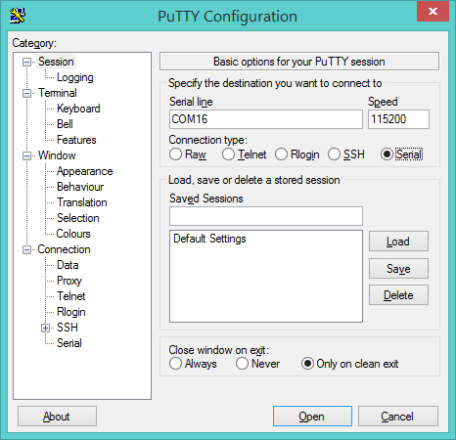

The PuTTY will open an Linux command window for you to use, and you can use the Linux commands to configure and to run the program on the Edison board. The followings are a list of common commands that can get you started using Linux:

ls List directory contents

cd .. Move up one directory

cd <foldername>

To enter into a folder/directory.

pwd

To print working directory (currently entered directory)

mkdir <newdirectoryname>

To create a new directory within the current directory

rmdir <directoryname>

To delete a non-empty directory in the current directory

mv <directory1/file1> <directory2/file2>

Move file1 from directory1 to directory2 and change name to file2

./<binname>

Run the executable called <binname>.

Example: ./run.sh

Now, we are ready to install software to Edison board..

### **3. Installing VIPLE Middleware on Robot Computer**

In order for the robot computer to create the JSON objects to be sent to the VIPLE program and to interpret JSON objects come from the VIPLE program, the robot computer need to have software. As a part of ASU VIPLE environment, a middleware for the robot to perform all the functions required on the robot side has been developed.

**Step 1**: Flash your Intel Edison board.

In order to run ASU VIPLE middleware on the robot, we need to install Linux operating system and devices drivers. For Intel Edison IoT board, we will follow Intel’s software and installation guide at: <https://software.intel.com/en-us/articles/flash-tool-lite-user-manual>

**Step 2**: Install ASU VIPLE Middleware

The Middleware will be hardware-dependent. ASU has implemented two alternative solutions for the users to download. Both set of software are open source, and the users can download and customize the software to adapt their hardware. Both middle can be downloaded from ASU VIPLE site at: [http://neptune.fulton.ad.asu.edu/VIPLE/](http://venus.eas.asu.edu/WSRepository/VIPLE/)

* The first middleware is implemented in JavaScript. It is easier for user to understand the code and to modify the code. After install the software, a user needs to use remote desktop to login into Edison and start the middle every time before VIPLE can connect to the Edison robot. For installing this middle, download it from ASU VIPLE site, Unzip the file and copy all the folders and files into the root folder of the Edison Board that runs Linux OS. To start the middleware, run the file run.sh. It will start the middleware and make the robot ready to work with ASU VIPLE program at the backend.
* The second middleware is mainly implemented in C++, and scripts are written to automate the start process. We need to remote log into Edison once only when we install the middleware. After the software is installed, the middleware will start automatically once the Edison board is powered up.

In this section, we will install and explain the second middleware.

Connect serially to the Edison board using the directions in Step 5 from Intel’s flashing instructions link in the previous step. Configure the Edison board to set up a name and password. Enter the command:

configure_edison --name

and follow the prompt to set a name for the Edison board. Then enter the command:

configure_edison --password

and follow the prompt to set a password for the Edison board. Please use 1234 as the password, so that other students can use the system without resetting the system.

Now when booting up, a name, for example “march2” will show up before login. Login as root with the password previously set (1234), as shown in the following screenshots.

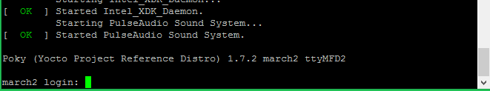

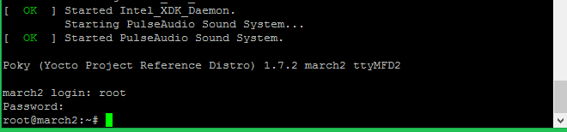

**Step 3**: Connecting to Wi-Fi Network

Configure the Edison board for WiFi. Enter the command:

configure_edison --wifi

After the available WiFi networks have been scanned and listed, enter the number for the selected router, for example: “asu” network SSID and enter “Y” when prompted., as shown in the following screenshot.

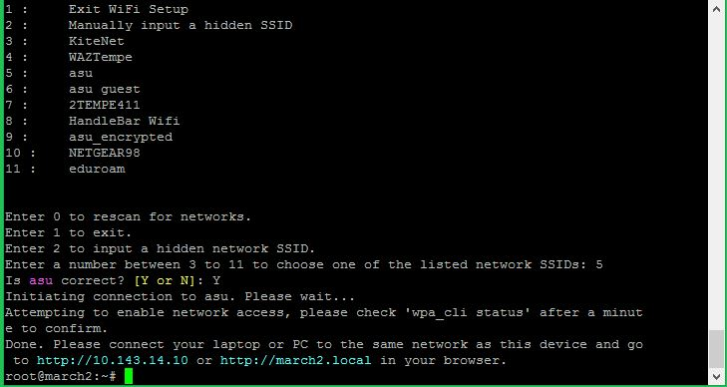

**Step 4**: Install the ASU Middleware automatically from Internet

After Wi-Fi is connected from the previous step, run this the following command:

curl –Ls https://goo.gl/gPTBWu | bash

This command will automatically install ASU VIPLE Middleware.

If this command does not succeed, you can run the command

curl –Ls https://goo.gl/gPTBWu

This command will open the script, and you can find the downloading address of ASU VIPLE Middleware. You can manually download the software and copy it into Edison’s root directory.

Notice, if your hardware (servos and sensors, and ports definitions) is different from ASU hardware (to be explained in the next section), you need to download the Middle and modify the Middleware to adapt to your hardware.

You need to have connected the LCD screen to the Edison board before you can perform the following step.

**Step 5:**

Once the VIPLE Middleware is running, the IP address of the Edison board will appear on the robot’s LCD screen, and you should be able to connect ASU VIPLE running on the backend to the Edison board.

Note: If you have not connected the LCD screen to the Edison board, you need to move the next lab to connect the LCD screen to the Edison board, and then come back to perform this step.

If the IP address does not appear in the LCD screen, disconnect, pause for 15 seconds, and reconnect the Edison power source.

### **4. Calibrating the Servos**

A servo motor has 3 wires. One connected to power and one to the ground. The third wire is for controlling the motion through pulses. A “pulse” is a short period of positive voltage on the wire, usually between 1000 and 2000 microseconds. Each position that the servo’s arm can move to has a unique pulse associated with it. When the Edison sends a pulse to the servo, the control circuit in the motor component will turn the arm to the position associated with that pulse. For example, if 1500 microseconds pulse is repeatedly sent to the servo, the servo will turn the arm to the position associated with the 1500 microseconds pulse. If 1800 microseconds pulse is repeatedly sent to the servo, the servo will turn the arm to the position associated with the 1800 microseconds pulse. Typically, a servo is supposed to move is arm to the 0° position when receiving a 1000 microseconds pulse, and move it to the 90° position when receiving a 2000 microseconds pulse. However, many servos support and require a wider pulse range and can turn the arm to any position. In this case, we need to calibrate the servo’s 0° position.

In this section, we give the instruction to calibrate the servos connected to our Edison robot.

Notice, if you have not connect the servo motor to the Edison board, you need to move to the next lab session to connect the servo motors to the robot, and then, come to back to here to calibrate the servos.

**Step 1: open putty and ssh into the Edison via one of two ways**

Immediately after seeing the ‘root@edison:#’ prompt (i.e. you are logged in), skip to II.

**(1) Over Wi-Fi**

The Edison board must be connected to Wi-Fi. Turn on Edison and find the IP address on the LCD screen. Type in IP Address into putty

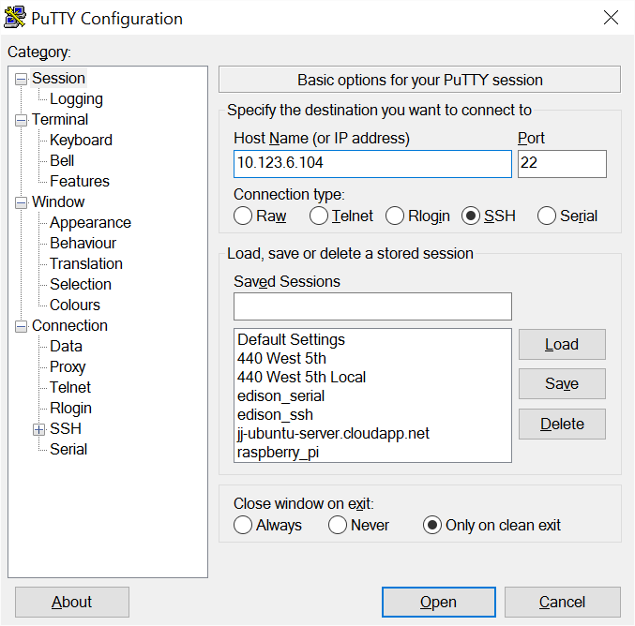

**(2) Over USB Connection**

The Edison board must be connected to the PC via micro USB with the switch toward the micro USB ports.

Open “Device Manager by clicking “Start” and typing in “Device Manager”.

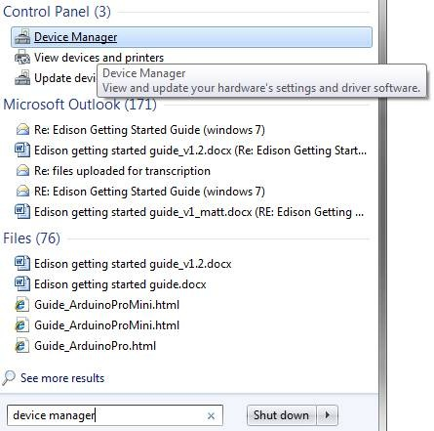

Scroll down to “Ports (COM & LPT)” and take note of the COM number listed under “USB Serial Port (COM#)”. In this example it will be COM11, as shown in the following figure.

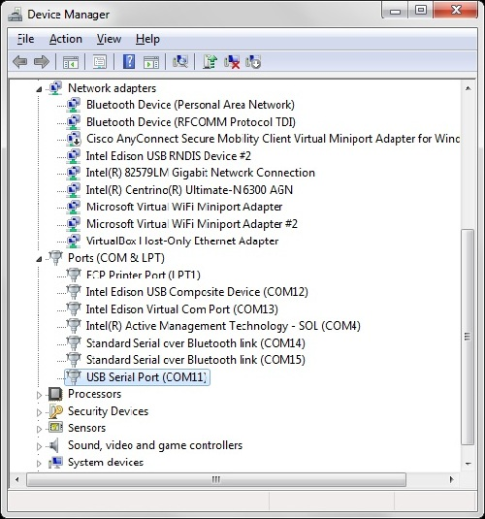

Open the PuTTY.exe application that you previously downloaded.

As shown in the following figure, at the top right of this screen, click on “Serial” and enter “COM11” (or the COM # that you see in Device Manager) in the “Host Name (or IP address) text area and enter “115200” in the “Port” text area.

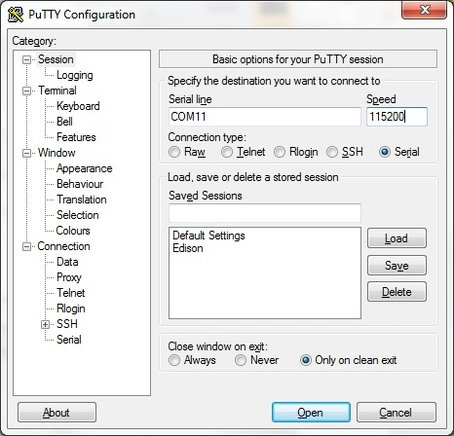

Click “Open.”

When you see the full black screen, press “Enter” two times.

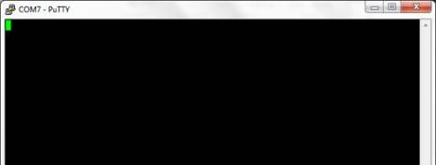

Type in “root” and press “Enter” – If you have previously configured Edison, use root and your password (1234) credentials that you configured.

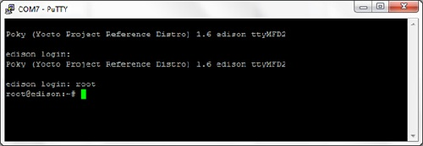

**Step 3: Run the Calibration Command**

Run the following command, replacing <*pin-num*> with the pin of the servo that you wish to calibrate (for example, 5 or 6 in our Edison configuration):

cd ~/IOT_Education/; servo_example/calibrate_servo <*pin-num*>

Repeat this step for each servo motors.

**Step 4: Calibrate the Servo**

Use a screw driver to rotate the servo calibration screw until the servo ceases spinning.

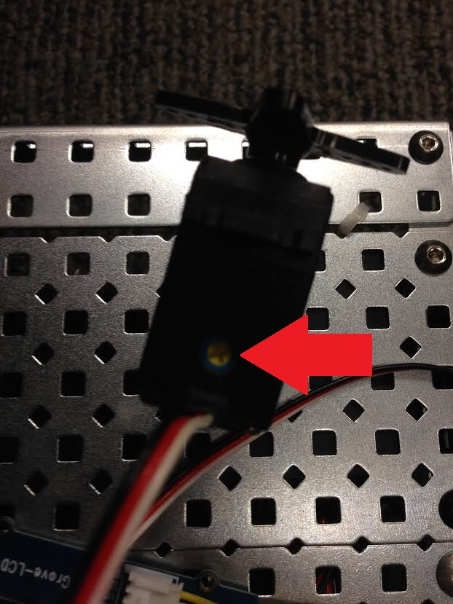

Port numbers (IDs) for sensors and motors in our current setting:

Ultrasonic Sensor: ID = 1

Touch Sensor: ID = 0

Left Servo: ID = 5

Right Servo: ID = 6

## Section 4. Testing your Software and Hardware

In the VIPLE program, we need to identify each sensor and each servo (motor) through device configuration, which include the main Robot, each sensor and each motor. Figure 3 shows the VIPLE code for testing the sensors connected to a robot, and Figure 4 shows the VIPLE code for testing the motors connected to a robot.

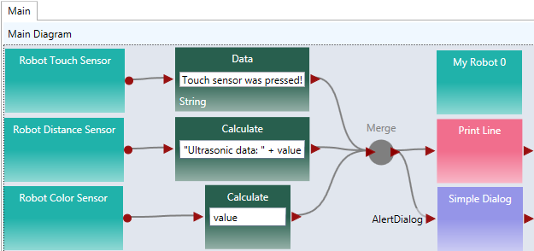

1. VIPLE code testing sensors



1. VIPLE code testing motors

In order for the main robot, the sensors, and the motors to communicate with VIPLE properly, we need to configure the partnership between the main robot and its devices, the IP address (physical or virtual), and the ports. Figure 5 shows the configuration of the three devices: main robot, drive (motors) and the distance sensor. Notice that the numbers may differ for different robot configuration. The IP address is from the robot, which will be displayed on the LED panel on the robot, once the robot is started. If virtual address is used, the display panel is not necessary.



1. Configuration of IoT device ports

### References

[1] ASU VIPLE: http://neptune.fulton.ad.asu.edu/VIPLE/

[2] Yinong Chen, W.T. Tsai, Service-Oriented Computing and Web Software Integration, 5th edition, Kendall/Hunt Publishing, 2015.

[3] Intel Edison assembling instruction: <https://software.intel.com/en-us/assembling-intel-edison-board-with-arduino-expansion-board>

[4] Connecting Edison board over USB: <https://software.intel.com/en-us/connecting-to-intel-edison-board-using-ethernet-over-usb>